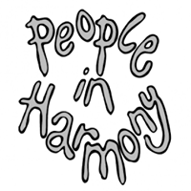
1972

PIH - Call for Your Views as a mixed race person or as a mixed race family

"The Stephen Lawrence Inquiry 20 years on”. What have we learnt? What still needs to be done?" - a participative conference that People in Harmony will be attending.

Here is what we would like to know:

- Does being a mixed race person in 2019 mean that you experience Hate Crime?

- Have you experienced racial harassment as a mixed race couple or family over this time?

- Have things improved over 20 years since Stephen’s murder?

- Has it got worse?

- Have you as a mixed race person personally, or as a mixed race family, had any involvement or benefited from any projects, or services, as a result of Hate Crime? (i) What was it? (ii) How did it help you?

- Did you report the incident? If no, why not?

- Do you know of any groups or initiatives who have provided support to counter racism?

- What more needs to be done?

Please send your comments to info@pih.org.uk no later than Wednesday midday March 27, stating the area you live in the UK here:
This will help provide information making the case from both an urban and a rural perspective.

We’d like to hear from you to enable us to represent the views from the mixed race community.

For and on behalf of People in Harmony

